# Kubernetes 3 Node Installation Using Kubeadm Steps:

Cloud: AZURE or GCP(Create Azure or Gcp Cloud account)

Vm’s: 3(one Master & two worker nodes)

OS: Ubuntu server 18(8gb or more ram and 4cpus for master)

If you are not able to create three Vm’s in same region we have to do Vnet Peering.

Master Node Worker Node1 & Node 2

Vnet:10.0.0.0/24 Vnet:10.0.0.2.0/24

Region: East US Region: south US

Kubeadm kubelet

Kubectl Docker

Kublet Kubeadm

Docker

Default ports for Master and worker nodes:

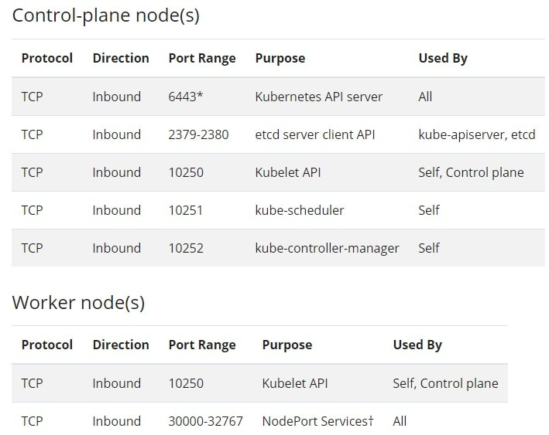

## Installing Docker,Kubectl and Kubeadm packages

Install these packages in master as well as in worker nodes

sudo su

Installing Docker:

apt-get update && apt-get install-y docker.io

docker –version

we have to download kubecadm and kubectl using https so install https

apt-get update && apt-get install-y apt-transport-https

Add GPG key for authenticate Kubernetes package.

curl -s https://packages.cloud.google.com/apt/doc/apt-key.gpg | apt-key add

Add Kubernetes to the package manager list

cat << EOF | sudo tee /etc/apt/sources.list.d/kubernetes.list

deb https://apt.kubernetes.io/​ kubernetes-xenial main

EOF

deb https://apt.kubernetes.io/ kubernetes-xenial main

apt-get update

apt-get install -y kubelet kubeadm kubectl

apt-mark hold kubelet kubeadm kubectl

Create a Kubernetes cluster:

We have to initialize kubeadm on the master node. This command will check against the node that we have all the required dependencies

kubeadm init

**Copy the kubeadm join command from the output**

Set env variables in the master to start using the cluster:

cp /etc/kubernetes/admin.conf $HOME/

chown $(id -u) $HOME/admin.conf

export KUBECONFIG=$HOME/admin.conf

Join the Worker nodes with the Kubernetes cluster:

SSH to worker node and run the join command which we copied earlier from the master node.

Test the cluster:

Run kubectl get nodes

Install CNI in master nodes to communicate with worker nodes

kubectl apply -f "https://cloud.weave.works/k8s/net?k8s-version=$(kubectl version | base64 | tr -d '\n')"

kubectl get nodes

kubectl get pods -n kube-system